Introduction to Networking and the OSI ModelTheory
1. Install Wireshark and identify protocol names
Wireshark is a network packet analyzer used to capture and examine the data sent and received by a computer over a network.
Practical steps
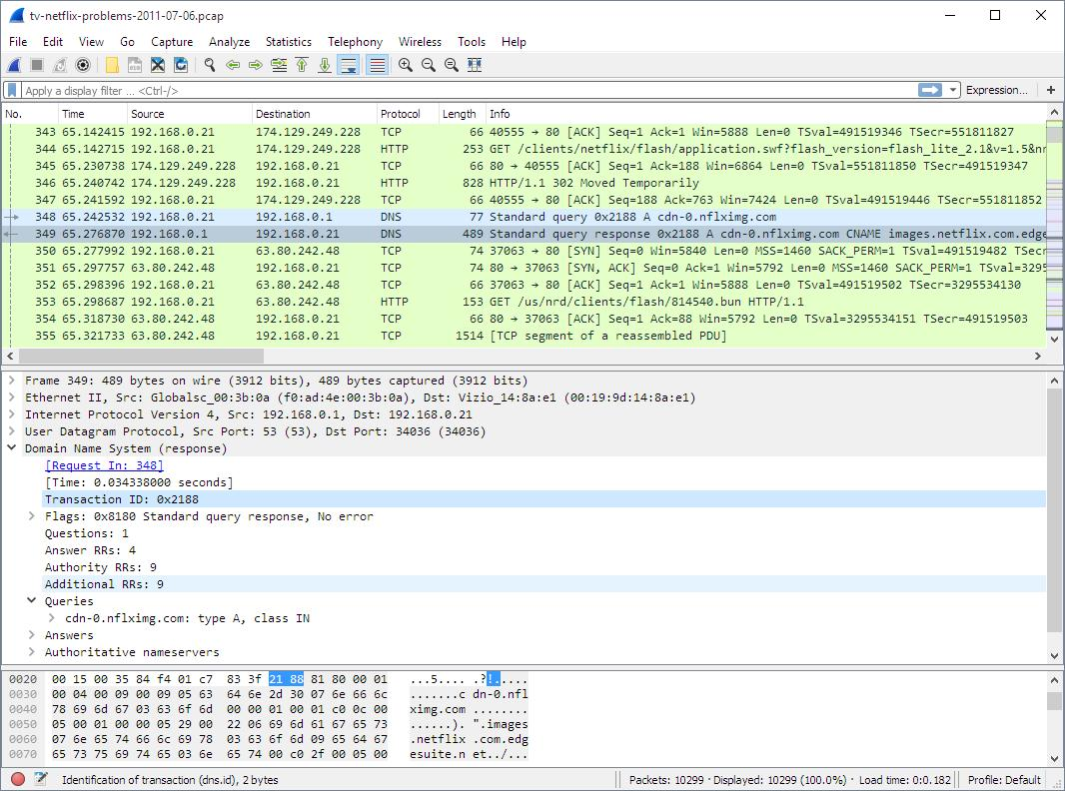
Step 1: Install Wireshark
Download it from the official website: wireshark.org. Install it on your laptop.
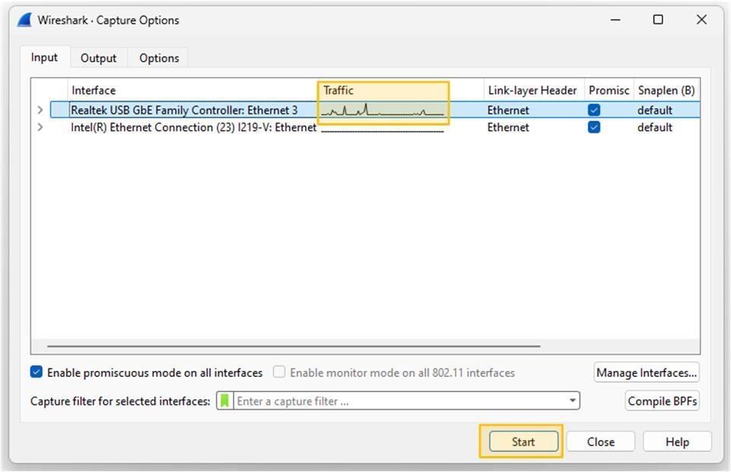
Step 2: Start capturing
Open Wireshark, select your active Wi-Fi or Ethernet interface, and click the blue shark-fin Start button.
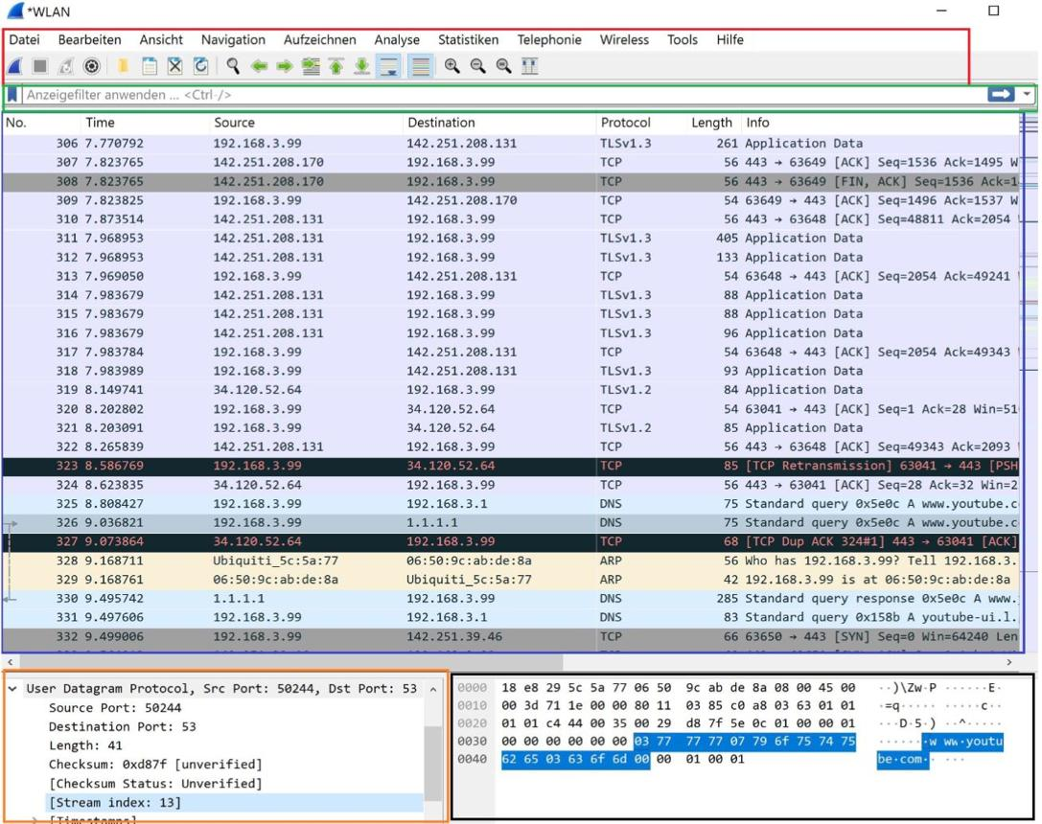
Step 3: Visit a website
Open your browser and visit https://www.instagram.com. Wait a few seconds, return to Wireshark, and click the red Stop button.
Protocol names you may observe
Your actual results will depend on your browser, network, and website. Common examples are:
Protocol | Full form / purpose
DNS | Domain Name System — resolves website names to IP addresses
TCP | Transmission Control Protocol — reliable data delivery
TLS | Transport Layer Security — encrypts network communication
QUIC | Quick UDP Internet Connections — supports fast, secure connections
UDP | User Datagram Protocol — sends datagrams without TCP-style reliability
HTTP | Hypertext Transfer Protocol — transfers web content
HTTP/3 | Third version of HTTP, carried over QUIC
ARP | Address Resolution Protocol — resolves IPv4 addresses to local MAC addresses
ICMP | Internet Control Message Protocol — network diagnostics and error reporting
IPv4 / IPv6 | Internet Protocol versions used for addressing and routing
Ethernet / 802.11 | Wired Ethernet / Wi-Fi network communication
Result: Wireshark can capture and display the protocols used during website communication. You may see HTTPS traffic represented by TLS or QUIC instead of readable HTTP content because the communication is encrypted.
2. Select any 3 packets and identify their OSI layers
Open your captured packets and check the Protocol and Info columns. Use the following example as a guide; replace these entries with the actual packets from your capture.
Packet | Protocol | Main OSI layer | Explanation
1 | HTTP | Layer 7 — Application | Handles web requests and responses.
2 | TCP | Layer 4 — Transport | Provides reliable delivery and connection management.
3 | TLS | Layer 6 — Presentation (conceptually) | Provides encryption and decryption functions.
Important: The OSI model is a conceptual model. Wireshark may show multiple protocols in one packet. For example, a TLS packet may be carried inside TCP, IP, and Ethernet or Wi-Fi frames. Modern Internet protocols do not always map neatly to one OSI layer.
If your capture shows DNS, TCP and TLS instead of HTTP, you can use those three protocols and explain their functions.
Result: Three captured packets can be examined to understand how network protocols relate to the OSI model.
3. Colorful OSI Model diagram with real-world examples
Use the colorful diagram above as a reference for drawing your assignment. The seven layers, from top to bottom, are:
7
Application Layer
WhatsApp — sending messages
6
Presentation Layer
Instagram — image formats and encryption functions
5
Session Layer
Netflix — maintaining a viewing session
4
Transport Layer
TCP — reliable data delivery
3
Network Layer
Google Maps — IP routing
2
Data Link Layer
Wi-Fi / Ethernet — local frames and MAC addresses
1
Physical Layer
Wi-Fi radio signals and Ethernet cables
Functions of all seven layers
Layer | Main function
7. Application | Provides network services to applications.
6. Presentation | Handles data representation, encoding, compression and encryption.
5. Session | Establishes, manages and terminates communication sessions.
4. Transport | Provides end-to-end delivery, segmentation and flow control.
3. Network | Handles logical IP addressing and routing.
2. Data Link | Handles frames, MAC addresses and local-link error detection.
1. Physical | Transmits raw bits as electrical, optical or radio signals.
How to draw it: Draw seven horizontal boxes in different colors. Write the layer number and name on the left, its function in the middle, and a real-world example on the right. You can draw it on paper or in MS Paint/Canva and upload a photo for your practical submission.
4. How a WhatsApp message travels through the OSI model
Suppose you type “Hello!” in WhatsApp and send it to your friend.

Step 1 — Application Layer (Layer 7)
You type “Hello!” and press Send. WhatsApp prepares the message for transmission.
Step 2 — Presentation Layer (Layer 6)
The data needs an appropriate format and encryption. WhatsApp uses end-to-end encryption for personal messages. Encryption is a presentation-layer function in the OSI model, although WhatsApp's actual implementation does not follow a strict seven-layer stack.
Step 3 — Transport Layer (Layer 4)
Transport protocols handle communication between endpoints. The application data is carried over the network using the transport protocol selected by WhatsApp's connection.
Step 4 — Network Layer (Layer 3)
IP addresses help route the data packets from your device across networks toward the destination server.
Step 5 — Data Link Layer (Layer 2)
Your device sends data in local network frames over Wi-Fi or a mobile network. On Wi-Fi, frames travel to the wireless router or access point.
Step 6 — Physical Layer (Layer 1)
The data travels as radio signals over Wi-Fi or a mobile network, or as electrical/optical signals through wired network equipment.
Step 7 — Receiving device
The data passes through the receiving device's networking stack and reaches WhatsApp, which decrypts the message for the intended recipient to read.
Conclusion
The OSI model explains how data travels from an application through the network to another device. Wireshark helps us observe real network protocols, while the seven-layer model helps us understand their roles. When a WhatsApp message is sent, data is prepared, protected, transported, routed and transmitted, then processed by the receiving device.

